# Week 1

* The four elements of effective data visualization are the information (data), the story (concept), the goal (function), and the visual form (metaphor); a successful data visualization must have all four elements.
* 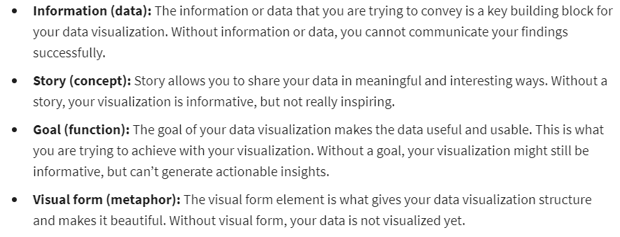
* 
* In Tableau, floating items can be layered over other objects. Tiled items are part of a single-layer grid that automatically resizes based on the overall dashboard size.
* 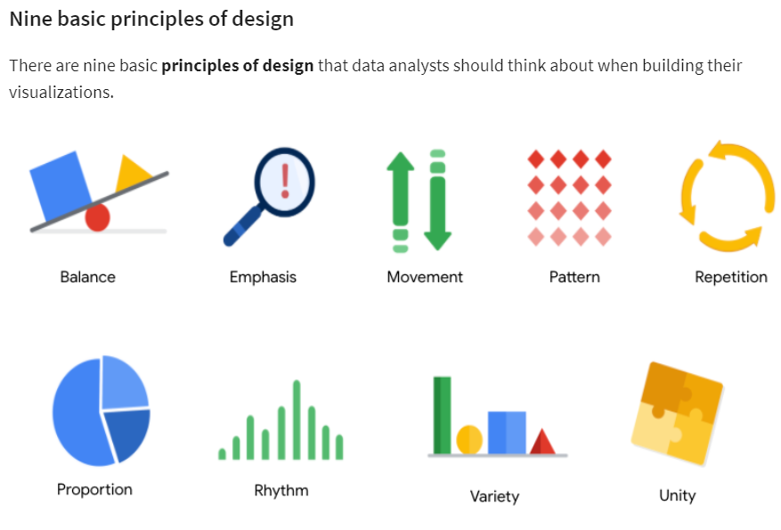
* Data composition: combining the individual parts in a visualization and displaying them together as a whole.
* Data visualizations have three essential elements: clear meaning, a sophisticated use of contrast, and refined execution. Refined execution means paying deep attention to detail. This is done by using visual elements such as lines, shapes, colors, value, space, and movement.
* Design thinking: a process used to solve complex problems in a user-centric way.
* Five phases of design process: empathize, define, ideate, prototype, test.
* 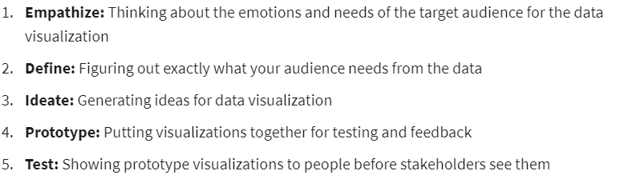

# Week 4

* An initial hypothesis is a theory you’re trying to prove or disprove with data. Examples of an initial hypothesis include: a trend of annual revenue growth from an increasing number of online sales, a relationship between the holiday season and increased traffic congestion, and an increase of wildlife presence from a record high in annual rainfall.
* In the McCandless Method, the first step involves communicating to the audience where they should focus and what the graphic is about. This is the step for introducing the graphic by name.
* 